Campaigning Requirements
- Applicants are prohibited from engaging in any campaign activities (including print/electronic solicitation & letters requesting support or chapter member’s votes) prior to the presentation and acceptance of the slate at the April chapter meeting.
- All campaigning must end prior to the start of the May chapter meeting.
- The amount a candidate may spend campaigning should not exceed $25.00.
- Violations of the campaigning procedures will result in disqualification.
- Alleged violations of the above guidelines shall be submitted directly to the Chair of the Nominating Committee.
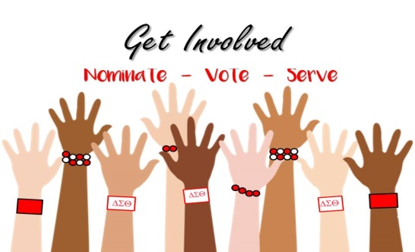
The Nominating Committee will provide a space for candidates to campaign if desired after the April Chapter Meeting!!!

Application Requirements
- Applicants must submit a COMPLETE typewritten Official Candidate Profile
- On areas of the Official Candidate Profile that do not pertain to the candidate one must indicate N/A. Incomplete applications will not be accepted
- Official Candidate Profile must include:
- A no more than 200-word essay outlining interest in the position
- Why candidate is uniquely qualified for the positon
- What candidate offers to the chapter in terms of leadership service and experience
- Candidates commitment to abide by the governing documents of the chapter
- Official Candidate profile must be signed and emailed or postmarked by 2/16/2019. Candidates who submit via email may use an electronic signature or type one’s name on the signature page.

See Union County Alumnae Policies and Procedures for an all-inclusive overview of the Nomination Process.

